# Tribhuvan University Institute of Science and Technology



**Central Department of Computer Science and Information Technology**

**Kirtipur, Kathmandu**

**Case Study Report**

**on**

**Membership Issuing in Tribhuvan University Central Library**

**Submitted By**

Raju Shrestha

MSC CSIT First Semester, Section B

Roll No. 48/079

**Submitted To**

Prof. Dr. Subarna Shakya

Central Department of Computer Science and Information Technology,

Tribhuvan University, Kirtipur

May, 2023

# Introduction

Tribhuvan University Central Library (TUCL) is the biggest library in Nepal and it was established in 1959 A.D. TUCL is an academic library established to support the teaching, study and research needs of the university campus, Kirtipur. TUCL is a huge resource for students, faculty, and researchers, providing access to a large collection of books, journals, and other academic materials. To ensure efficient utilization of its resources, the library operates a membership system. This system allows individuals to become a registered members and enjoy various privileges, such as issuing book, borrowing books, accessing online databases, and utilizing study spaces. The process of membership issue involves specific procedures and requirements that individuals must fulfill to obtain library membership. In this case study, I will explore the details of the membership issuing process in the Tribhuvan University Central Library, highlighting the steps involved and the benefits it offers to its members.

# Problem Statement

The current process of membership issuing in the Tribhuvan University Central Library faces various challenges and shortcomings that hinder the efficient and effective management of library memberships. These challenges include lengthy and cumbersome procedures, lack of clear guidelines for applicants, limited availability of resources for verifying applicant information, and delay in processing membership requests. These issues lead to frustration among potential members, decreased user satisfaction, and a strain on library staff resources. Thus, there is a need to identify and address these problems in order to streamline the membership issuing process and enhance the overall experience for individuals seeking to become members of the Tribhuvan University Central Library.

# Objective

The objective of this case study is to analyze and improve the process of membership issue in the Tribhuvan University Central Library. The study aims to identify the existing challenges and shortcomings in the current process, propose practical solutions to streamline the membership issuing procedure, enhance user experience, and optimize the utilization of library resources. The objective is to develop a more efficient, user-friendly, and effective system for issuing library memberships that meets the needs of both the library staff and the potential members. Shortly the objective of this case study is as following.

1. Analyze and improve the process of membership issuing in the Tribhuvan University

Central Library.

1. Identify the existing challenges and shortcomings in the current process.

# Related Work

The related works that I found and can be considered for the case study on "Membership Issuing in Tribhuvan University Central Library" are:

1. "Best Practices for Library Membership Systems in Academic Institutions"

This research paper explores successful practices implemented in other academic libraries for membership issuing processes. It highlights efficient workflows, user friendly interfaces, and innovative approaches to enhance user experience and streamline the membership process.

1. "Case Study: Improving Membership Issuing Process at XYZ University Library"

This case study examines a similar university library's journey to enhance their membership issuing process. It details the challenges faced, strategies employed, and the outcomes achieved. It can provide valuable insights and lessons learned that can be applicable to the improvement of Tribhuvan University Central Library membership issuing process.

1. "User Satisfaction and Challenges in Library Membership Processes"

This survey-based study investigates user satisfaction levels and challenges faced by library users during the membership issuing process. It explores factors such as ease of application, documentation requirements, waiting time, and clarity of instructions. The findings can help identify common pain points and inform improvements.

1. "Automation and Integration of Library Membership Systems: A Comparative Study" This comparative study analyzes different library automation systems that integrate membership issuing processes. It evaluates their features, functionality, and user experiences. By reviewing this study, insights can be gained into potential software solutions or system integrations for Tribhuvan University Central Library.
2. "Improving Efficiency and User Experience in Library Membership Processes through Digital Solutions"

This article focuses on the utilization of digital solutions, such as online applications, self-service kiosks, and mobile apps, to enhance efficiency and user experience in library membership processes. It discusses the benefits, challenges, and implementation strategies of such digital solutions.

# Methodology

1. **Process (Life Cycle) Model**

Requirement

Gathering and Analysis of

Membership Issuing

Design of Gathered

Requirements

Implementation

*Drawing 1: Process Diagram of Library Membership Issuing System*

1. Data Collection

For this case study I have used the interview data collection technique to gather the information from the Tribhuvan University Central Library management system official about the membership issuing process. I have found that the process and the type of library membership is distributing as follows.

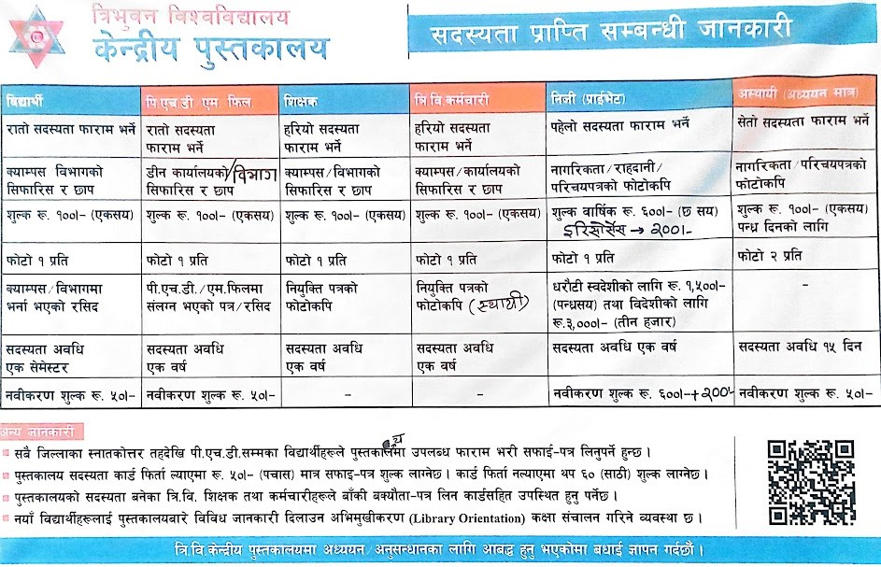

*Figure 1: Membership Issuing Process and Type of Membership of TUCL*

3. Use Case/UML

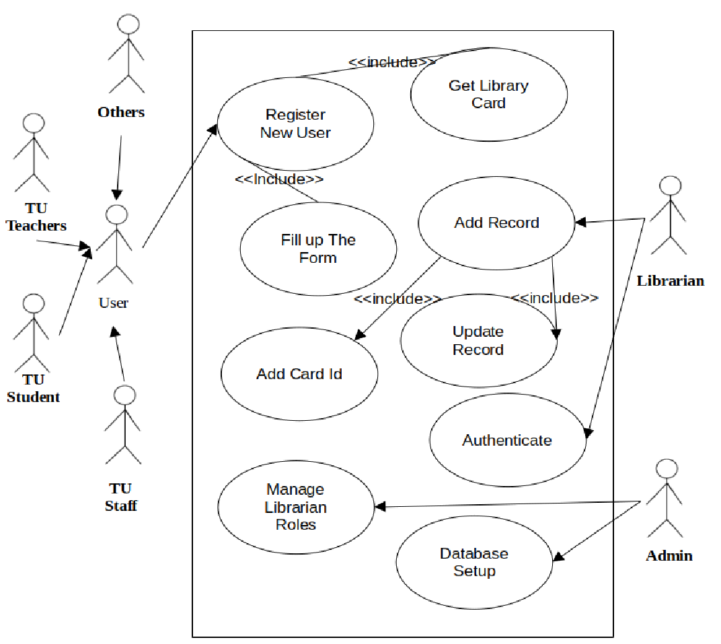

*Figure 2: Use Case Diagram for the TUCL Membership Issuing Process*

# Implementation

I have found that "Membership Issuing in Tribhuvan University Central Library" is using the Koha open source library management system. While I would like to recommend the use of a custom object-oriented software system instead of Koha. To implement these I recommend following steps.

1. Define Requirements: Collaborate with library staff, administrators, and potential users to gather detailed requirements for the custom software system. Understand the specific functionalities, workflows, and features needed for the membership issuing process.
2. Design the System: Utilize object-oriented software engineering principles to design the architecture, modules, and user interfaces of the custom software system. Identify the necessary classes, relationships, and interactions between different software components.
3. Develop the System: Implement the designed system by writing code based on the object-oriented design. Utilize appropriate programming languages and frameworks to develop the software system, ensuring it meets the identified requirements.
4. Integrate Data: Integrate the custom software system with the existing data and systems within the Central Library of Tribhuvan University. This includes ensuring compatibility with existing databases, integrating user information, and connecting to relevant library resources.
5. Test the System: Conduct comprehensive testing of the custom software system to ensure its functionality, performance, and reliability. This includes unit testing, integration testing, and user acceptance testing to validate that the system works as expected.
6. Train Staff: Provide training sessions for library staff to familiarize them with the custom software system. Train them on how to use the system, handle membership issuing tasks, and troubleshoot common issues.
7. Deploy the System: Install and configure the custom software system in the library's infrastructure. This may involve setting up servers, databases, and necessary software dependencies.
8. Monitor and Support: Continuously monitor and maintain the custom software system to address any issues, bugs, or performance bottlenecks. Provide ongoing support to library staff and users, ensuring that any concerns or problems are promptly addressed.
9. Evaluate and Improve: Continuously evaluate the effectiveness of the custom software system in improving the membership issuing process. Gather feedback from library staff and users and make necessary improvements or enhancements based on their input.

By following this implementation process, the Tribhuvan University Central Library can successfully develop and deploy a custom object-oriented software system tailored to their specific membership issuing needs. This will allow them to optimize the process, enhance user experience, and efficiently manage membership-related tasks.

# Outcomes

The outcomes of the case study on "Membership Issuing in Tribhuvan University Central Library" include several positive changes and improvements. Here I listed are some of them.

1. Streamlined Membership Process: The Membership Issuing system in Tribhuvan University Central Library should use Streamlined Membership Process that reduces waiting times, minimizing paperwork, and improving overall efficiency.
2. Enhanced User Experience: The Membership Issuing system in Tribhuvan University Central Library should use the Enhanced User Experience that can gain insights into user expectations, pain points, and preferences regarding the membership process. By addressing these factors, the library can enhance the user experience, making it easier, more convenient, and user-friendly for individuals to become members of the library.
3. Efficient Data Management: Implementing a custom software system can help automate and streamline data management processes related to membership issuing. The outcome would be improved accuracy, ease of data retrieval, and better data organization, enabling the library to make informed decisions based on comprehensive and up-to-date membership data.
4. Reduce the type of Membership: I have found that the Membership Issuing system in Tribhuvan University Central Library is issuing 4 different type of membership (TU Teachers, TU Students, TU Staff, Others). I suggest that the membership type should be reduced into 2 types that is one for the TU Teachers, Students and Staffs and another one is for other users.

# Conclusion

The case study on "Membership Issuing in Tribhuvan University Central Library" concludes that rather than using Koha (The open source system software for library management system) TUCL should build a custom and specific object oriented software system to manage the overall process of the library. By doing this membership issuing becomes a sub-process of the TUCL and we can change any component of TUCL as required at any time.

The study identified several key challenges in the membership issuing process, including lengthy processing times, cumbersome paperwork, and user dissatisfaction. These challenges highlighted the need for a more streamlined and user-friendly approach.

By recommending the development of a custom object-oriented software system, the study proposed a tailored solution to address the identified challenges. This custom software system offers the advantages of flexibility, scalability, and alignment with the specific requirements of Tribhuvan University Central Library.

Furthermore, the study emphasized the importance of enhancing the user experience by focusing on accessibility, and efficient data management. These aspects are crucial in ensuring a positive and inclusive experience for library members.

# References

https://scholar.google.com/ <https://openai.com/>

https://scihub.se/